FINAL PROJECT

POSITION KINEMATICS FOR DELTA ROBOT

**TEAM MEMBERS:** Varun Sanghvi, Nivedha Sivakumar

**TEAM NUMBER:** FINAL PROJECT-4

**GOAL**: The goal of this final project is to design, build and analyze the position kinematics of a delta robot.

**DELTA ROBOT- DESIGN AND QUALITATIVE ANALYSIS:**

A delta robot is a type of [parallel robot](https://en.wikipedia.org/wiki/Parallel_robot) that consists of three arms connected to [universal joints](https://en.wikipedia.org/wiki/Universal_joints) at the base. The key design feature is the use of [parallelograms](https://en.wikipedia.org/wiki/Parallelogram) in the arms, which maintains the orientation of the [end effector](https://en.wikipedia.org/wiki/Industrial_robot_end_effector). Industries that take advantage of the high speed of delta robots are the packaging industry, medical and pharmaceutical industry. For its stiffness, it is also used for surgery. Other applications include high precision assembly operations in a [clean room](https://en.wikipedia.org/wiki/Clean_room) for electronic components. The structure of a delta robot can also be used to create [haptic](https://en.wikipedia.org/wiki/Haptic_technology#Games) controllers. More recently, the technology has been adapted to [3D printers](https://en.wikipedia.org/wiki/3D_printers). These printers can be built for about a thousand dollars and compete well with traditional Cartesian printers.

We have designed and built a delta robot with 3 DOF, i.e., the robot can exhibit motion in X, Y and Z directions as detailed in figures below. The circuit design for motor movement, and the 3-D symbolic representation of the delta robot are as illustrated below.

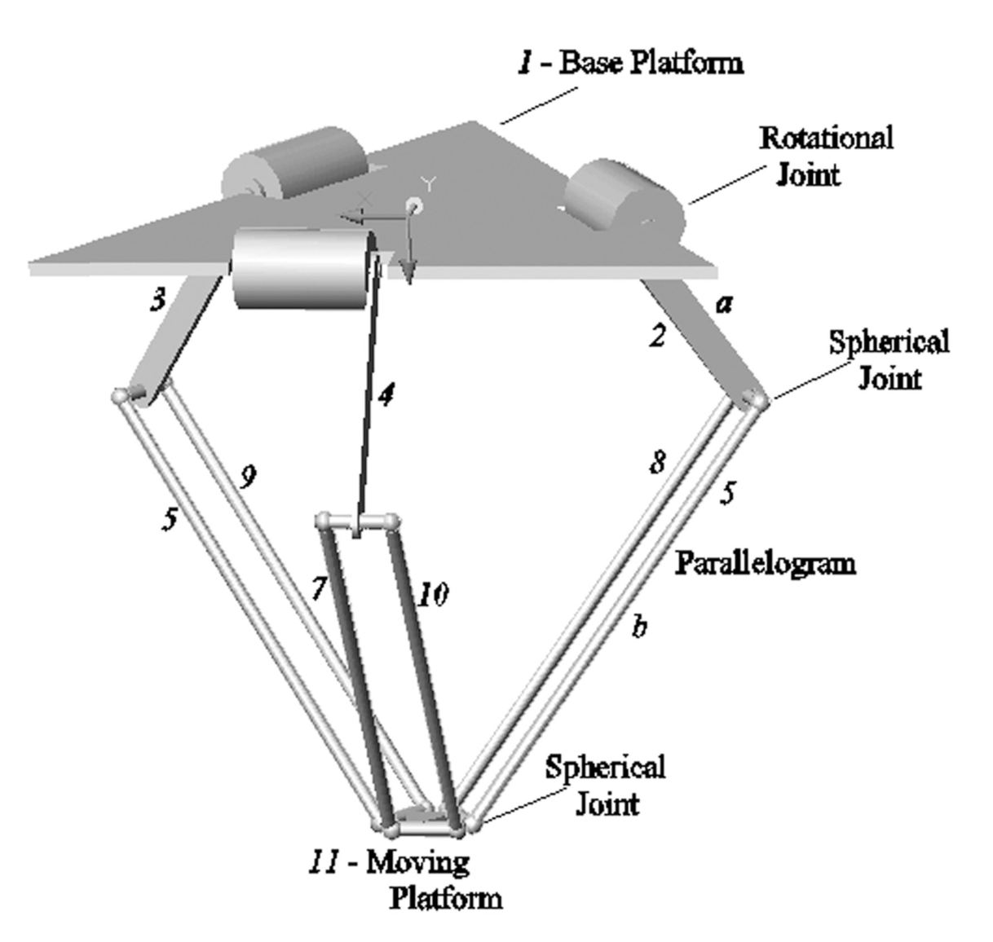

FIG 1. 3-D representation of delta robot

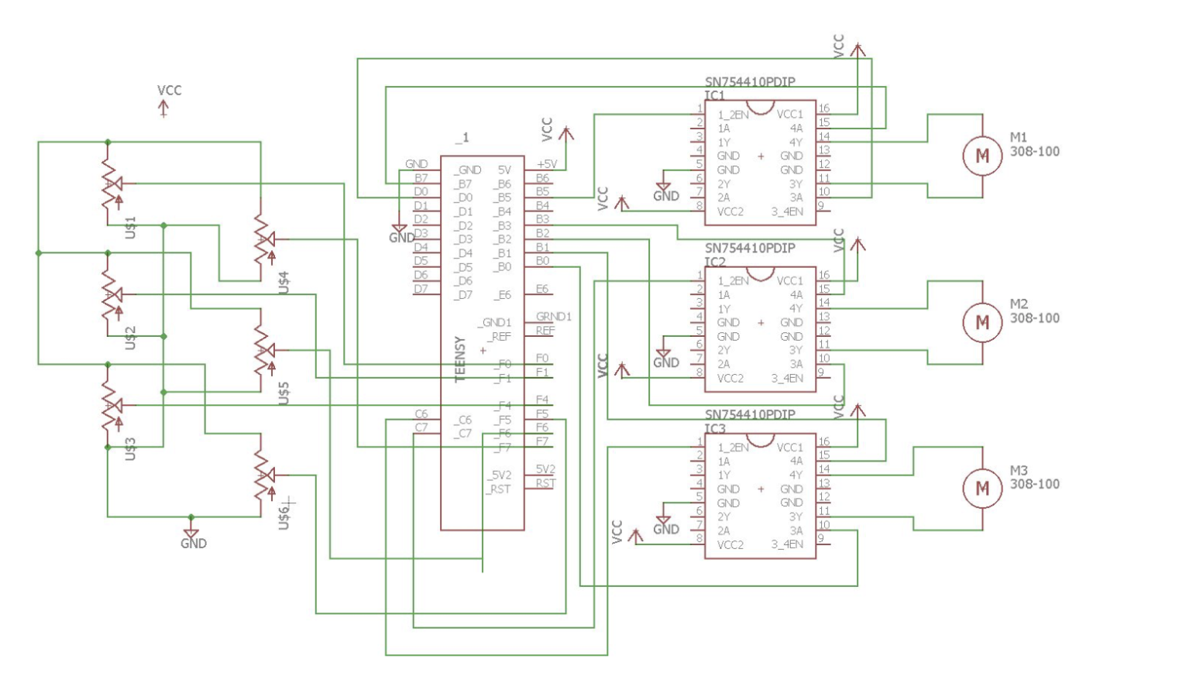

FIG 2. CIRCUIT DESIGN FOR MOTOR MOVEMENT

The designed robot has only revolute and spherical joints, its kinematic arrangement is found to be RUU (U represents the universal joints used in the delta robot, which are implemented using 3 non-collocated revolute joints).

This qualitative analysis of DOF estimation is backed up by the Kutzbach mobility equation given below:

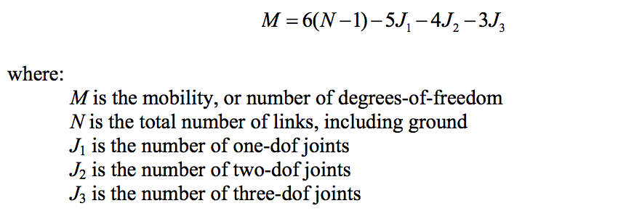

Substituting for N, J1 , J2 and J3 as 14, 15, 0 and 0 (as per design of the delta robot) in the Kutzbach equation, we obtain a DOF of 3.

**METHOD:**

The kinematic scheme of the delta robot is as illustrated below. The delta robot has 2 equilateral triangle platforms: moving platform with the end-effector, and stationary one with the motors. As evident from figure below, the joint angles are theta1, theta2 and theta3, the end-effector position is Eo (xo, yo and zo).

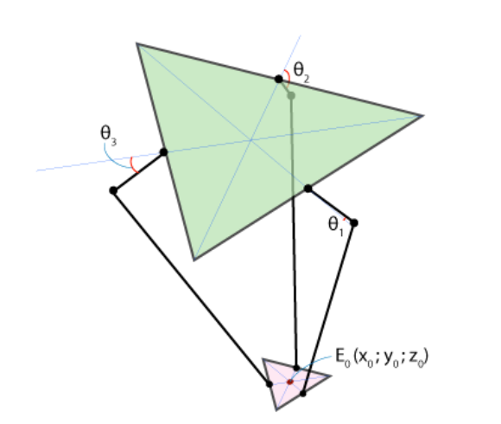

FIG 3. SCHEMATIC OF DELTA ROBOT

1. **Inverse Position Kinematics for Delta robot:**

Given a desired end-effector position, the solution for joint angles of robot is inverse kinematics. For parallel robots, it is easier to identify the inverse kinematics solution before forward kinematics (as multiple forward solutions exist for parallel robots). Therefore, we will first solve for inverse position kinematics on the delta robot. We use the geometric approach to solve this problem as it is much simpler than the analytical approach.

Consider the following parameters that depend on robot geometry designed:

* f – fixed platform equilateral triangle
* e – moving platform with end-effector
* rf – length of upper joint
* re – length of parallelogram joint

As the delta robot is designed to have a reference frame with its origin at the center of symmetry of the fixed triangle (as illustrated below), the z-axis is always pointed towards the negative direction.

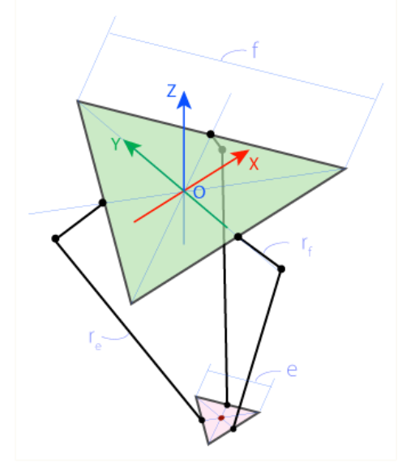

FIG 4. FRAME OF REFERENCE FOR FIXED PLATFORM

Joint F1J1 can only rotate in YZ plane, hence tracing a circle (as illustrated in figure below) at center at F1 with radius rf. J1 and E1 are the universal joints. Similarly, the joint E1 and J1 can trace a sphere relative to E1 at center E1 and radius re. The intersection of the formed sphere and YZ plane of the robot is circle at center E1’ and radius E1’J1 (E1’ is the projection of point on the YZ plane). Now, point J1 can be estimated from the intersection of circles (of known radius) at centers E1’ and F1. Once J1 is calculated, we can easily arrive at the joint angle theta1 using the below equations.

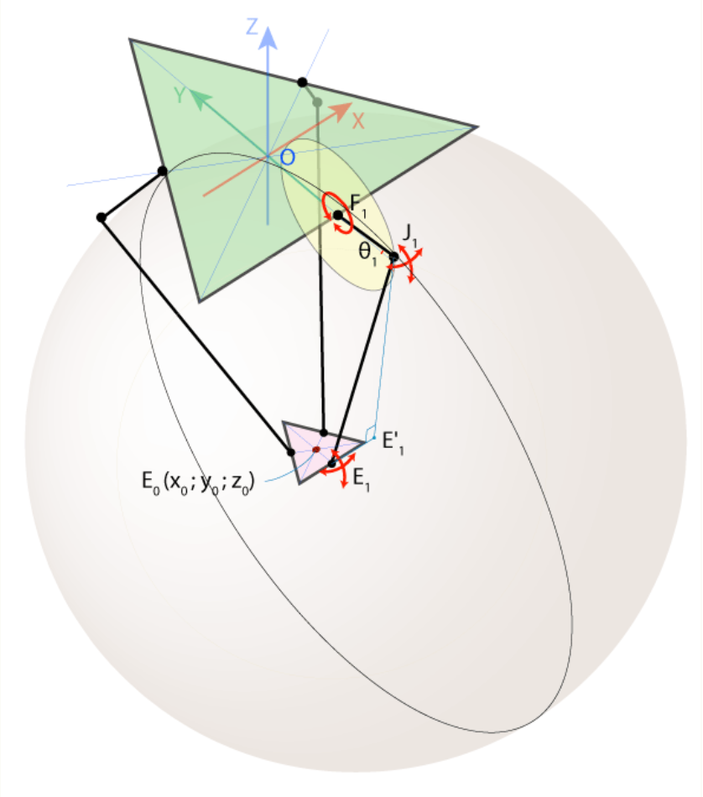

FIG 5. TRAJECTORY OF F1J1 JOINT MOVEMENT IN YZ PLANE

Using the symmetry of the parallel robot to our advantage, we can estimate angles theta2 and theta3. Upon choosing a frame of reference that has a joint moving in a single plane, we can omit the 3rd axis. To use this concept to calculate theta2 and theta3, we can rotate the coordinate system in XY plane about the Z axis by an angle of 1200 counterclockwise to obtain a new frame of reference as shown in figure below. We can easily the joint angle theta2 from the new frame of reference X’Y’Z’ in a manner similar to calculation of theta1. The only difference in calculation is that we must now determine co-ordinates x0’ and y0’ of E0. This can be achieved using corresponding rotation matrix (to account for the rotated in frame of reference). Similarly, theta3 can be found by rotating frame of reference in a clockwise direction.

EQUATIONS TO SOLVE FOR THETA1, AND BY EXTENSION THETA2 AND THETA3:

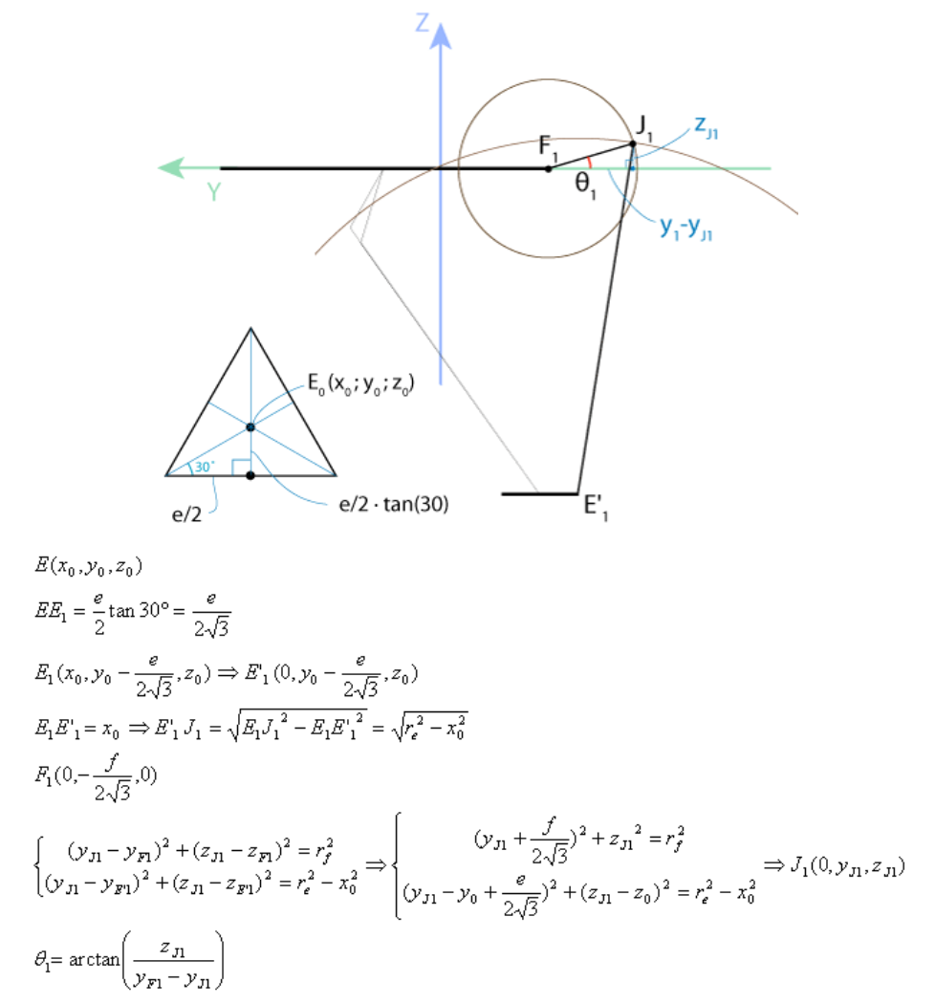

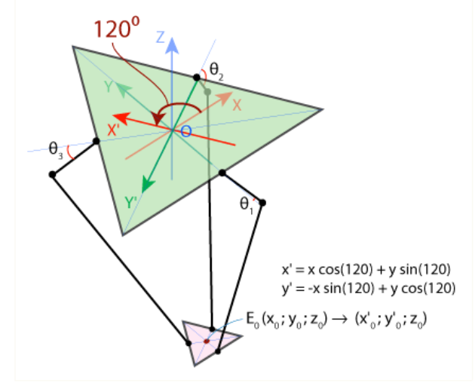

FIG 6. ROTATION OF XY PLANE ABOUT Z AXIS TO FIND THETA2

Hence, we can solve the inverse kinematics problem using the geometric approach in manner described above to find the joint angles theta1, theta2 and theta3.

1. **Forward Position Kinematics for Delta robot:**

Finding the position of the end-effector given the joint angles of the robot is the forward kinematics solution. Solving this problem is generally very difficult as it requires the solution of multiple coupled nonlinear algebraic equations. Multiple valid solutions generally exist. As the 3-DOF delta robot is translation only, there exists a straightforward analytical solution for which the correct solution is easily chosen.

Given the 3 joint angles theta1, theta2 and theta3, we can find the coordinates of points J1, J2 and J3. It is evident from the figure below that joints J1E1, J2E2 and J3E3 can freely rotate around joints J1, J2 and J3, respectively (this movement will trace circles of radius re).

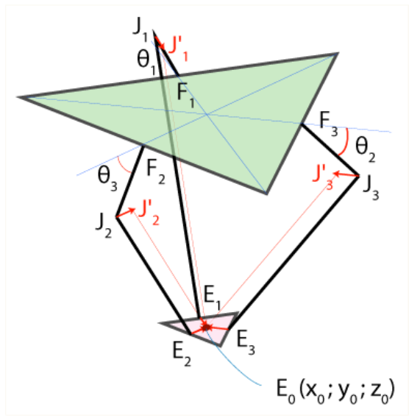

FIG 7. SCHEMATIC REPRESENTATION FOR FORWARD POSITION KINEAMTICS

By transitioning the center of these spheres from J1, J2 and J3 to J1’, J2’ and J3’ using E1E0, E2E0 and E3E0 as ‘transition vectors’, the spheres will now intersect at point E0 as shown in figure below:

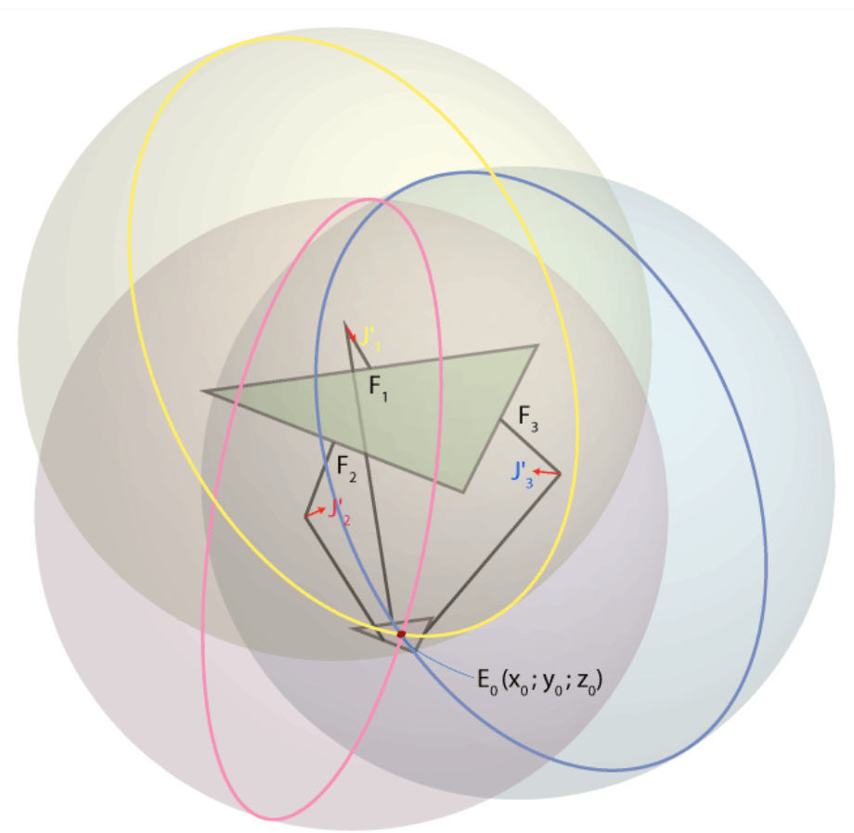

FIG 8. INTERSECTION OF TRASITIONED CENTERS OF SPHERES

Now, to arrive at the end-effector co-ordinates of E0, we can solve the equations of form (x-xj)^2+(y-yj)^2+(z-zj)^2 = re^2 for these 3 spheres simultaneously (as shown below). Before that, to find the coordinates of transformed points J1’, J2’ and J3’ we follow the setup below:

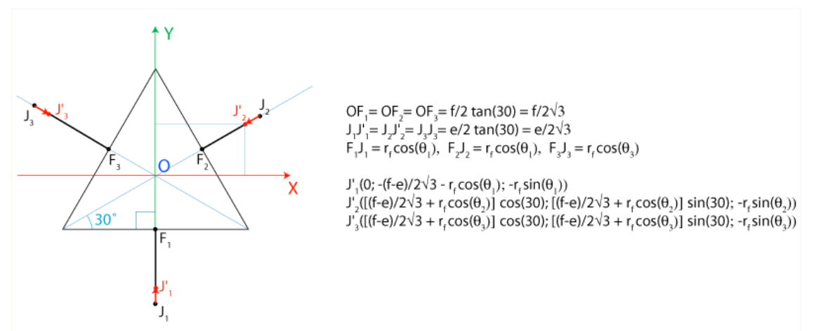

FIG 9. TO FIND COORDINATES OF J1’, J2’ AND J3’

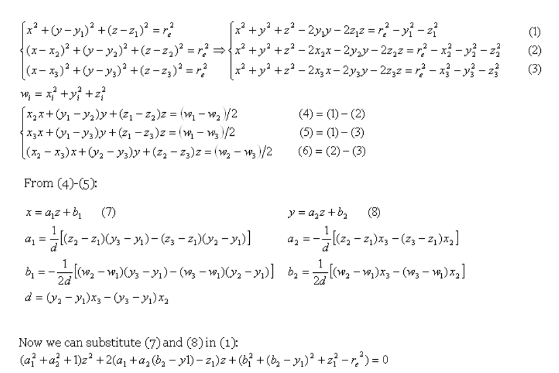

Hence, we can solve the forward kinematics problem using the geometric approach in manner described above to find the end-effector co-ordinates.

**EVALUATION:**

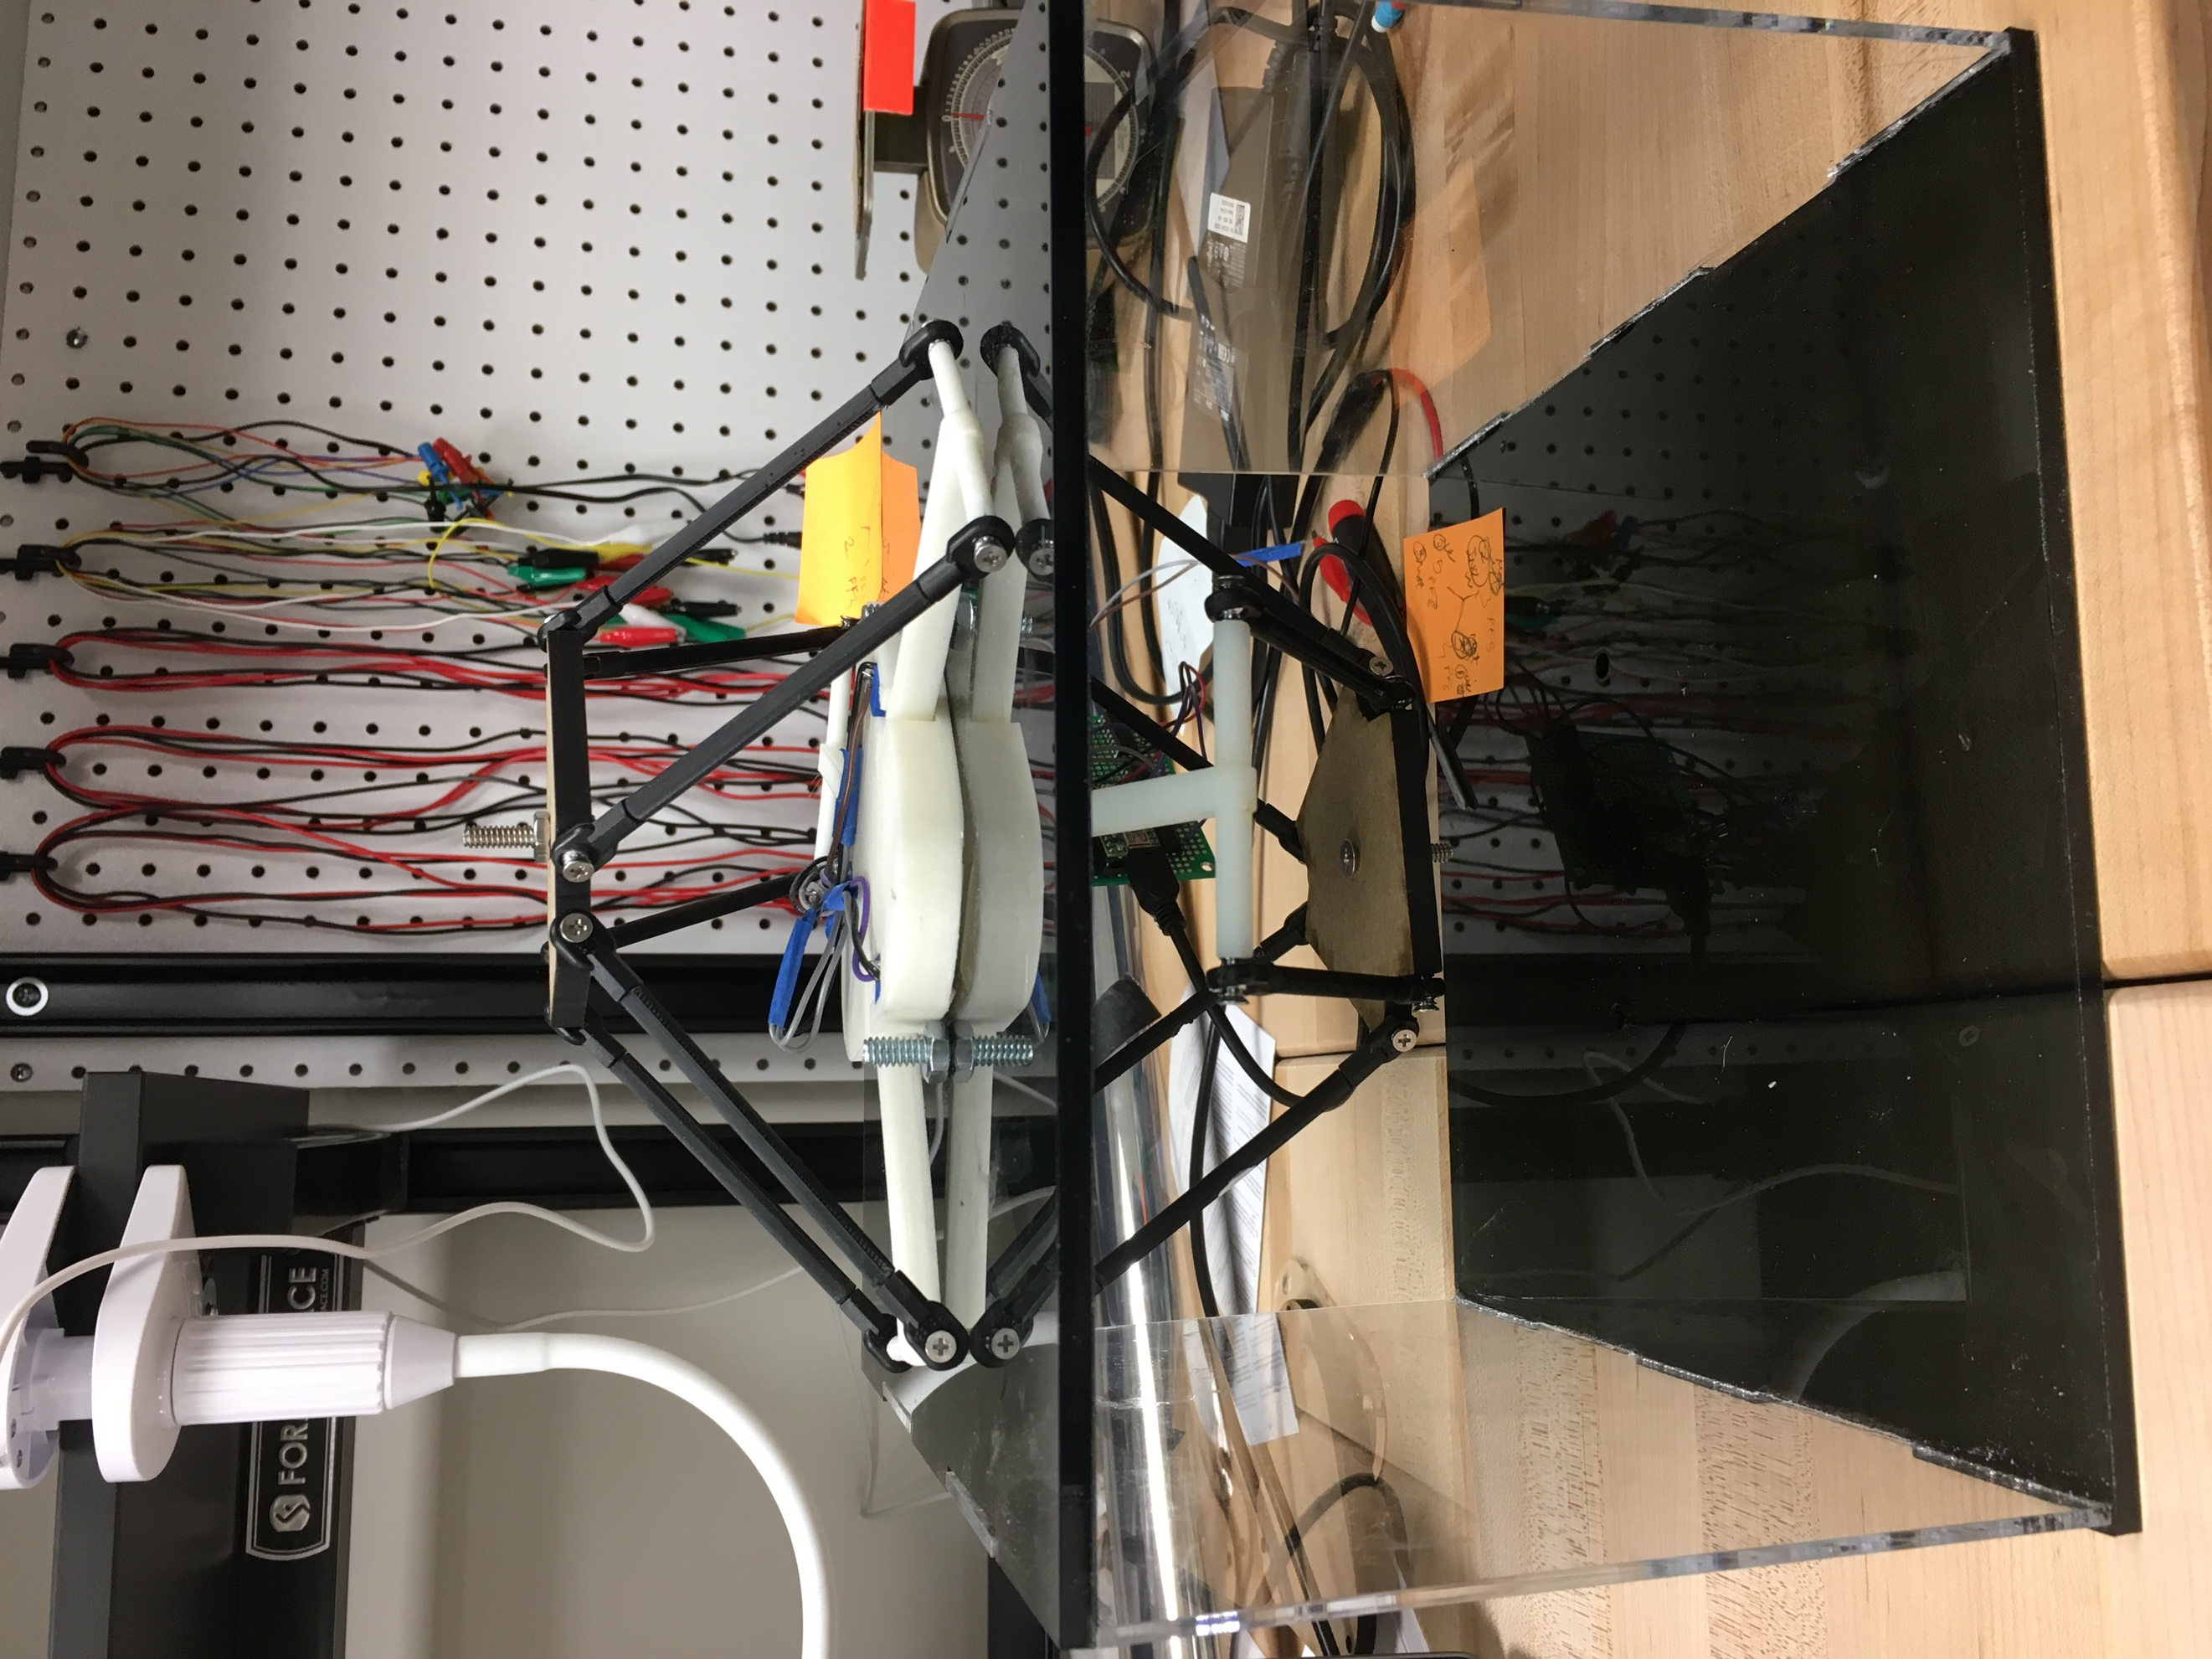

FIG 10. MASTER-SLAVE ARRANGEMENT OF DELTA MANIPULATORS

We have setup 2 delta manipulators in an arrangement as illustrated above. The manipulator on top acts as a master for forward kinematics. Upon moving the forward arm using the end-effector, the joint angles of the master manipulator is transmitted to the slave manipulator. We have tuned a PID controller to ensure that master-to-slave joint angle control is satisfactory. We then perform forward kinematics to identify end-effector position given the joint angles. For inverse kinematics, the slave manipulator acts independently. Given an end-effector position, the inverse kinematics equations problem is solved to identify joint angles to achieve given end-effector position. It is important to note that the workspace of the 3-arm delta robot is hemi-spherical at the lower boundaries. An example for robot workspace is as illustrated below:

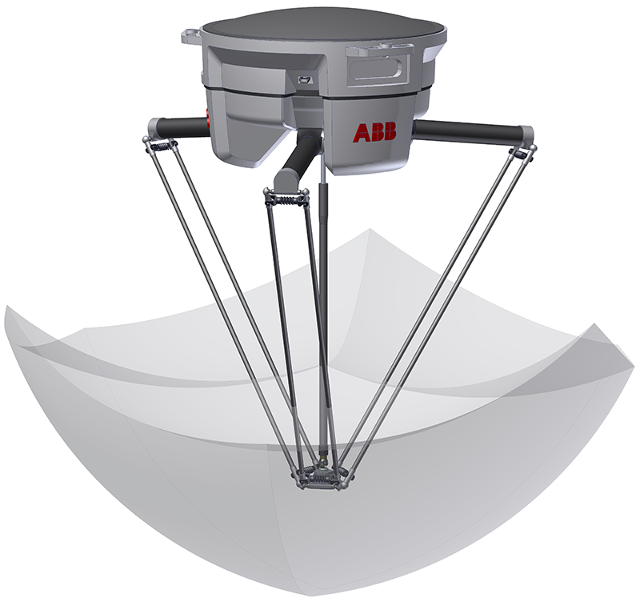

FIG 11. EXAMPLE WORKSPACE OF 3-ARM DELTA ROBOTS

1. **Forward Kinematics:** To illustrate the forward position kinematics, we have run multiple tests (attached as videos). The evaluation of correctness of forward position kinematics was performed with following test cases:

**TEST 1- WITHIN REACHNABLE WORKSPACE:** In video FK_TEST1, we have fed in joint values to slave manipulator by movement to master joints within the reachable workspace of delta robot. It can be observed that the joint angles of slave reflect these changes to master joint angles. The end-effector position is then computed using the forward kinematics solution described above, and the end-effector position is being computed.

**TEST 2- AT THE EDGE OF REACHABLE WORKSPACE:** In video FK_TEST2, we fed in joint values such that the end-effector was aligned with the edge of the possible physical workspace of designed delta robot. The kinematic solution works well for the same, it can be seen that the end-effector of the slave moves in accordance with the input values.

**TEST 3- OUTSIDE REACHABLE WORKSPACE:** In video FK_TEST3, we fed in end-effector positions that are beyond the reachable workspace of the slave delta robot. It can be seen that the joints are unable to move to this end-effector position.

1. **Inverse Kinematics:** The evaluation of inverse position kinematics was done by marking the end-effector positions on a piece of paper as shown in figure below. Consider (0,0) to be the zero position of delta robot on that surface.

**TEST 1 - ZERO POSITION (0, 0):** For a given end-effector position (0,0), we can observe that the inverse kinematics solution works as expected. Given an end-effector position, the inverse kinematics solution for joint angles is calculated, and the manipulator moved to the zero position correctly. The output for this can be observed in video IK_TEST1.

**TEST 2- TARGET POSITION (0, 3.4**): It can be observed in video IK_TEST2 that the joint angles are calculated to move the end-effector to target position.

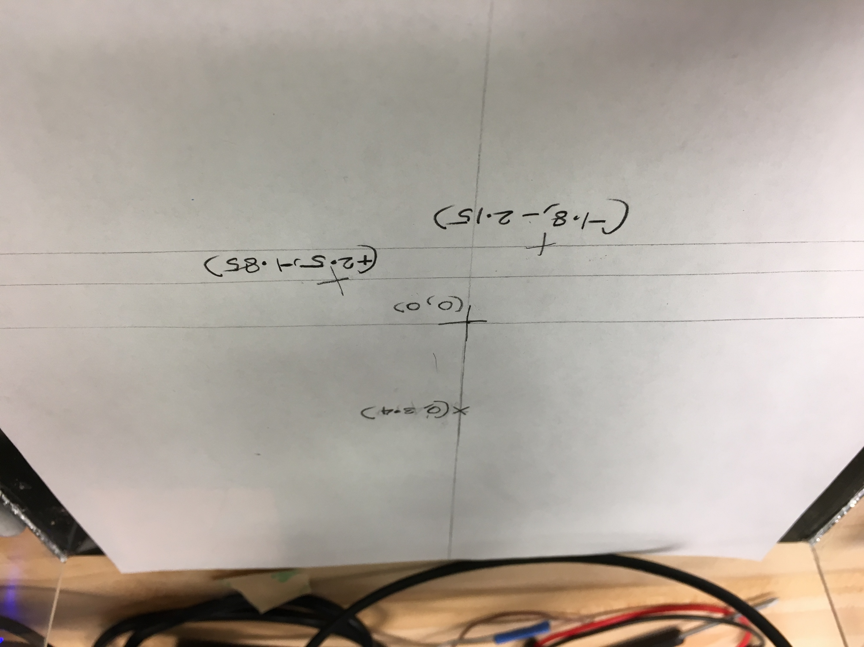

FIG 11. INVERSE POSITION KINEMATICS TEST CASES

**TEST 3- TARGET POSITION (2.5, -1.85):** From video IK_TEST3, the end-effector moves to the correct target position. However, the overshoot before reaching the target position is evident. We have attributed this to the imperfect tuning of PID controller. Also, although this point is within reachable workspace of delta robot, it is on the edge. At the edge of the reachable workspace of the robot, a small change is angle contributes to a large distance change. This validates the general idea of delta robots being more precise at the center of its workspace.

**TEST 4- TARGET POSITION (-1.8, -2.15):** From video IK_TEST4, the end-effector moves to the target position. As in the previous test case, overshoot before reaching the target position is evident. Additionally, we can also notice that the placement of end-effector is with slight deviation. This deviation can be attributed to the fact that the equipment for delta robot was 3-D printed, and the joints are slightly inaccurate. Hence, the manipulator moves at slight angular offset.

**PSEUDO CODE:**

**ANALYSIS:**

COMPARISON WITH EXPECTED RESULTS:

Upon testing the delta manipulator constructed with the kinematics solutions derived, we found the design and derived solution to work well for the following cases:

* Movement of manipulator within reachable workspace
* Forward and inverse kinematics solutions were tested and were found to be satisfactory
* The manipulator movement at the center of workspace works particularly well and relatively accurate.
* The delta robot movements are found to be quicker than Lynx movements
* Although there is a mild droop of the delta manipulator, it is significantly better than that of lynx

Despite all the above positives, the results obtained varied from the ideal results. This deviation can be attributed to the following factors:

* **Imperfect PID tuning:** Given more time, we would tune the PID controller to prevent overshoot, and smooth movement of delta manipulator.
* **Inherent nature of delta robots:** Delta robots are expected to be more precise at the center of workspace than it is at the edges (at the edge of workspaces, small change is joint angles result in large distance changes).
* **Mechanical imperfections:** The printed elements of the delta robot are inaccurate, and the joints are loosely held together. Given more time, we will use build/print better/sturdier equipment for more accurate positioning of manipulator.

**FUTURE SCOPE OF PROJECT:**

Although we studied parallel robots in class, we did not extensively analyze the kinematics of the same. We found this to be a good opportunity to utilize the skills acquired through this course and exercise the same. We also found the final project to be a good opportunity to understand current literature on robots/kinematics. The scope of this project is not limited to current implementation, given more time we could have explored the following avenues.

* Velocity kinematics analysis on delta robot to identify which method works better (position or velocity kinematics) for various applications.
* Modelling physical equipment and PID control for this specific implementation.

Applications of the constructed delta robot, after incorporation of the above changes can extend to:

* Haptic applications
* Sketching robots
* Pick-and-place operations
* Surgical applications
* High speed packaging
* Construction of 3D printers

**REFERENCES:**

1. [**http://www.cim.mcgill.ca/%7Epaul/clavdelt.pdf**](http://www.cim.mcgill.ca/%7Epaul/clavdelt.pdf)
2. [**http://forums.trossenrobotics.com/tutorials/introduction-129/delta-robot-kinematics-3276/**](http://forums.trossenrobotics.com/tutorials/introduction-129/delta-robot-kinematics-3276/)
3. [**https://en.wikipedia.org/wiki/Delta_robot**](https://en.wikipedia.org/wiki/Delta_robot)
4. [**https://www.marginallyclever.com/other/samples/fk-ik-test.html**](https://www.marginallyclever.com/other/samples/fk-ik-test.html)
5. [**https://robotics.stackexchange.com/questions/3144/inverse-kinematics-of-parallel-manipulator-delta-robot**](https://robotics.stackexchange.com/questions/3144/inverse-kinematics-of-parallel-manipulator-delta-robot)